>> A=imread('OrangeFlower.jpg');
>> greenData= A(:,:,2);
>> A(1675:1684,:)

....

Columns 2809 through 2816

23 22 19 17 16 15 15 15
21 21 20 18 17 15 14 14
20 20 18 18 17 15 15 15
21 20 19 18 17 16 15 15
22 21 19 19 19 17 16 15
19 18 19 20 19 17 16 15
19 18 17 16 16 16 16 16
20 19 17 16 16 16 16 16
21 21 19 17 16 16 16 15
20 21 20 18 15 15 15 13

>> greenData(:,975: 984)

''''
100 101 102 101 99 100 102 100 96 95
102 103 103 102 103 106 103 99 99 97
104 104 103 103 103 107 104 99 102 100
103 102 104 106 105 107 106 102 103 101
104 106 104 106 102 103 106 105 104 101
100 101 103 101 103 104 105 105 102 101
101 102 104 103 102 102 103 104 103 101
101 102 104 105 103 100 102 104 106 102
100 100 101 102 101 98 101 104 105 103
99 98 99 100 101 101 102 103 103 103
102 100 100 101 103 104 105 104 104 105
105 106 101 101 105 105 106 104 103 104
103 104 102 104 106 106 108 107 106 105

68 69 67 70 66 65 67 66 65 65
70 72 70 70 68 69 70 68 67 66
70 71 69 68 69 72 71 67 67 65
70 70 67 67 69 73 70 65 66 64
65 64 68 70 69 71 70 66 67 65
66 70 68 72 68 69 70 69 68 65
63 68 70 70 69 70 69 69 67 66
62 64 69 68 67 67 68 69 69 67
59 60 62 63 64 63 64 71 72 70
60 60 59 60 62 61 63 69 71 69
64 63 64 65 63 63 64 65 68 68
72 70 69 70 70 71 67 66 66 67
76 77 74 74 74 74 71 69 66 67
75 76 76 77 76 76 73 72 69 68

>> im = B;C

...

70 72 70 70 68 69 70 68 67 66
70 71 69 68 69 72 71 67 67 65
70 70 67 67 69 73 70 65 66 64
65 64 68 70 69 71 70 66 67 65
66 70 68 72 68 69 70 69 68 65
63 68 70 70 69 70 69 69 67 66
62 64 69 68 67 67 68 69 69 67
59 60 62 63 64 63 64 71 72 70
60 60 59 60 62 61 63 69 71 69
64 63 64 65 63 63 64 65 68 68
72 70 69 70 70 71 67 66 66 67
76 77 74 74 74 74 71 69 66 67
75 76 76 77 76 76 73 72 69 68

>> display(im)

Columns 8443 through 8448

14 12 10 9 9 9
14 12 11 9 8 8
13 13 13 11 10 10
14 13 13 12 11 11
14 14 14 12 11 10
13 14 13 11 11 10
11 10 11 11 11 11
11 10 11 11 13 13
14 12 11 11 13 12
15 13 13 13 13 11

>> max(max(im))

ans =

212

>> min(min(im))

ans =

0

>> im .* 2

...
Columns 8443 through 8448

28 24 20 18 18 18
28 24 22 18 16 16
26 26 26 22 20 20
28 26 26 24 22 22
28 28 28 24 22 20
26 28 26 22 22 20
22 20 22 22 22 22
22 20 22 22 26 26
28 24 22 22 26 24
30 26 26 26 26 22

>> im2 = im .* 2

9. Display the values of the elements in im2. Are the results what you expected? EXPLAIN YOUR RESULTS IN THE WRITE-UP PORTION OF THIS ASSIGNMENT.

>> imDouble1= double(im)

...
Columns 8446 through 8448

9 9 9
9 8 8
11 10 10
12 11 11
12 11 10
11 11 10
11 11 11
11 13 13
11 13 12
13 13 11

12. Display the values of the elements in imDouble12. How do they differ from im2. EXPLAIN YOUR RESULTS IN THE WRITE-UP PORTION OF THIS ASSIGNMENT.

>> im2double(im)

Columns 8443 through 8448

0.0549 0.0471 0.0392 0.0353 0.0353 0.0353
0.0549 0.0471 0.0431 0.0353 0.0314 0.0314
0.0510 0.0510 0.0510 0.0431 0.0392 0.0392
0.0549 0.0510 0.0510 0.0471 0.0431 0.0431
0.0549 0.0549 0.0549 0.0471 0.0431 0.0392
0.0510 0.0549 0.0510 0.0431 0.0431 0.0392
0.0431 0.0392 0.0431 0.0431 0.0431 0.0431
0.0431 0.0392 0.0431 0.0431 0.0510 0.0510
0.0549 0.0471 0.0431 0.0431 0.0510 0.0471
0.0588 0.0510 0.0510 0.0510 0.0510 0.0431

14. Display the values in imDouble2. How do they differ from Double1. EXPLAIN YOUR RESULTS IN THE WRITE-UP PORTION OF THIS ASSIGNMENT

>> mat2gray(im);
>> imDouble3= mat2gray(im);
>> display(imDouble3);

Columns 8445 through 8448

0.0472 0.0425 0.0425 0.0425
0.0519 0.0425 0.0377 0.0377
0.0613 0.0519 0.0472 0.0472
0.0613 0.0566 0.0519 0.0519
0.0660 0.0566 0.0519 0.0472
0.0613 0.0519 0.0519 0.0472
0.0519 0.0519 0.0519 0.0519
0.0519 0.0519 0.0613 0.0613
0.0519 0.0519 0.0613 0.0566
0.0613 0.0613 0.0613 0.0519

How do they differ from imDouble2? EXPLAIN YOUR RESULTS IN THE WRITE-UP PORTION OF THIS ASSIGNMENT

16. In the write up portion of this assignment in addition to describing the results from steps 1-13 above in a separate section summarize the differences between the following Matlab operations:
16a. double
16b im2double
16c. im2double(double(im))
16d. mat2gray

Yeah, it's not well described. But a simple test will show you that
when you use im2double, it will convert your uint8 image from the
range of 0-255 into a double array in the range 0-1. In general, all
Image Processing Toolbox functions that take floating point arrays
want them in the range of 0 to 1. I find it kind of annoying but
that's the way it is. That's basically what "rescaling" means. So
this imdouble() function is there to help you get to what you might
need for later calls to Image Processing Toolbox functions. If you
use double() you would have to divide by 255 yourself if you needed
to. If you're doing your own custom functions then you can leave it
in the original range if you want.

>> help double
DOUBLE Convert to double precision.
DOUBLE(X) returns the double precision value for X.
If X is already a double precision array, DOUBLE has
no effect.

DOUBLE is called for the expressions in FOR, IF, and WHILE loops
if the expression isn't already double precision. DOUBLE should
be overloaded for all objects where it makes sense to convert it
into a double precision value.

double

Convert to double precision
Syntax

double(x)

Description

double(x) returns the double-precision value for X. If X is already a double-precision array, double has no effect.
Remarks

double is called for the expressions in for, if, and while loops if the expression isn't already double-precision. double should be overloaded for any object when it makes sense to convert it to a double-precision value.

>> help im2double
IM2DOUBLE Convert image to double precision.
IM2DOUBLE takes an image as input, and returns an image of class double. If
the input image is of class double, the output image is identical to it. If
the input image is not double, IM2DOUBLE returns the equivalent image of
class double, rescaling or offsetting the data as necessary.

I2 = IM2DOUBLE(I1) converts the intensity image I1 to double
precision, rescaling the data if necessary.

RGB2 = IM2DOUBLE(RGB1) converts the truecolor image RGB1 to
double precision, rescaling the data if necessary.

I = IM2DOUBLE(BW) converts the binary image BW to a double-
precision intensity image.

X2 = IM2DOUBLE(X1,'indexed') converts the indexed image X1 to
double precision, offsetting the data if necessary.

Class Support
-------------
Intensity and truecolor images can be uint8, uint16, double, logical,
single, or int16. Indexed images can be uint8, uint16, double or
logical. Binary input images must be logical. The output image is double.

Example
-------
I1 = reshape(uint8(linspace(1,255,25)),[5 5])
I2 = im2double(I1)

See also double, im2single, im2int16, im2uint8, im2uint16.

Reference page in Help browser
doc im2double

Image Processing Toolbox™ Provide feedback about this page
im2double

Convert image to double precision
Syntax

I2 = im2double(I)
RGB2 = im2double(RGB)
I = im2double(BW)
X2 = im2double(X,'indexed')

Description

I2 = im2double(I) converts the intensity image I to double precision, rescaling the data if necessary.

If the input image is of class double, the output image is identical.

RGB2 = im2double(RGB) converts the truecolor image RGB to double precision, rescaling the data if necessary.

I = im2double(BW) converts the binary image BW to a double-precision intensity image.

X2 = im2double(X,'indexed') converts the indexed image X to double precision, offsetting the data if necessary.
Class Support

Intensity and truecolor images can be uint8, uint16, double, logical, single, or int16. Indexed images can be uint8, uint16, double or logical. Binary input images must be logical. The output image is double.
Examples

I1 = reshape(uint8(linspace(1,255,25)),[5 5])
I2 = im2double(I1)

>> help mat2gray
MAT2GRAY Convert matrix to intensity image.
I = MAT2GRAY(A,[AMIN AMAX]) converts the matrix A to the intensity image I.
The returned matrix I contains values in the range 0.0 (black) to 1.0 (full
intensity or white). AMIN and AMAX are the values in A that correspond to
0.0 and 1.0 in I. Values less than AMIN become 0.0, and values greater than
AMAX become 1.0.

I = MAT2GRAY(A) sets the values of AMIN and AMAX to the minimum and maximum
values in A.

Class Support
-------------
The input array A can be logical or numeric. The output image I is double.

Example
-------
I = imread('rice.png');
J = filter2(fspecial('sobel'), I);
K = mat2gray(J);
figure, imshow(I), figure, imshow(K)

See also gray2ind, ind2gray, rgb2gray.

Reference page in Help browser
doc mat2gray

m2double

Convert image to double precision
Syntax

I2 = im2double(I)
RGB2 = im2double(RGB)
I = im2double(BW)
X2 = im2double(X,'indexed')

Description

I2 = im2double(I) converts the intensity image I to double precision, rescaling the data if necessary.

If the input image is of class double, the output image is identical.

RGB2 = im2double(RGB) converts the truecolor image RGB to double precision, rescaling the data if necessary.

I = im2double(BW) converts the binary image BW to a double-precision intensity image.

X2 = im2double(X,'indexed') converts the indexed image X to double precision, offsetting the data if necessary.
Class Support

Intensity and truecolor images can be uint8, uint16, double, logical, single, or int16. Indexed images can be uint8, uint16, double or logical. Binary input images must be logical. The output image is double.
Examples

I1 = reshape(uint8(linspace(1,255,25)),[5 5])
I2 = im2double(I1)

1. Read in the jpg image OrangeFlower (available from course webpage)
>> A=imread('OrangeFlower.jpg');
2. Display the image with the title 'Orange Flower'
>> image (A) ; title (‘Orange Flower’);
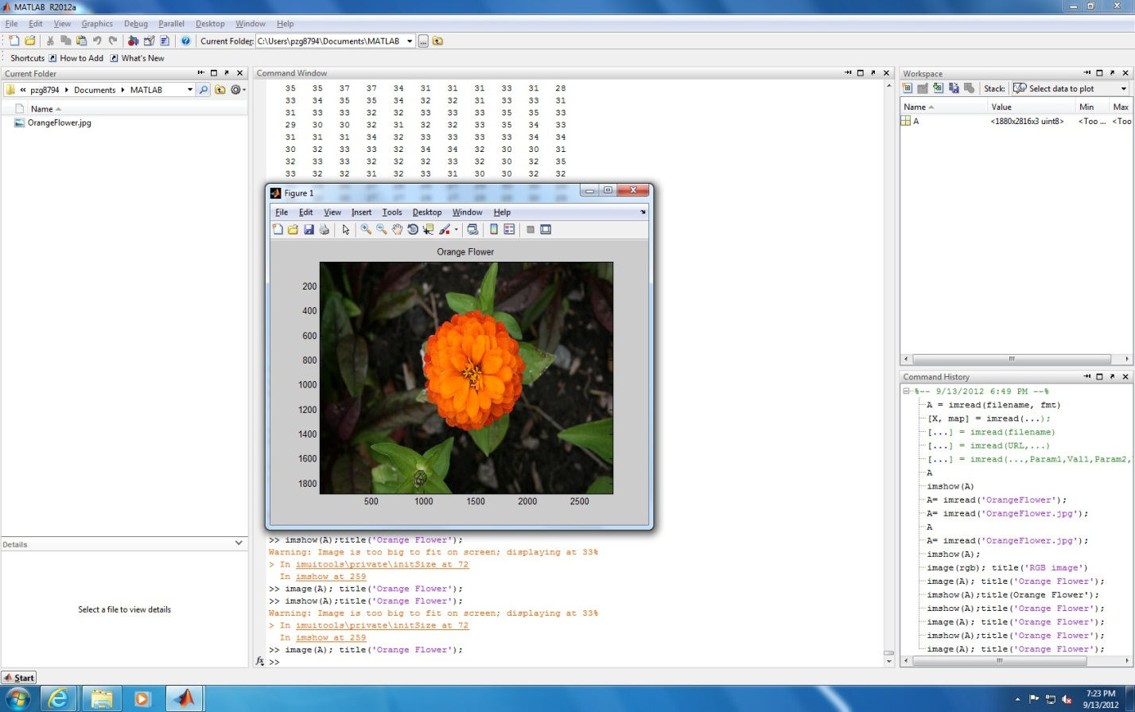

3. Display only the green pixel plane of the image and title Orange Flower Green Pixel Data
>> figure; image(A(:,:,2)); tittle(‘Orange Flower Green Pixel Data’); colormap([zeros(256,1), [0:1/255:1]’, zero(256,1)]);
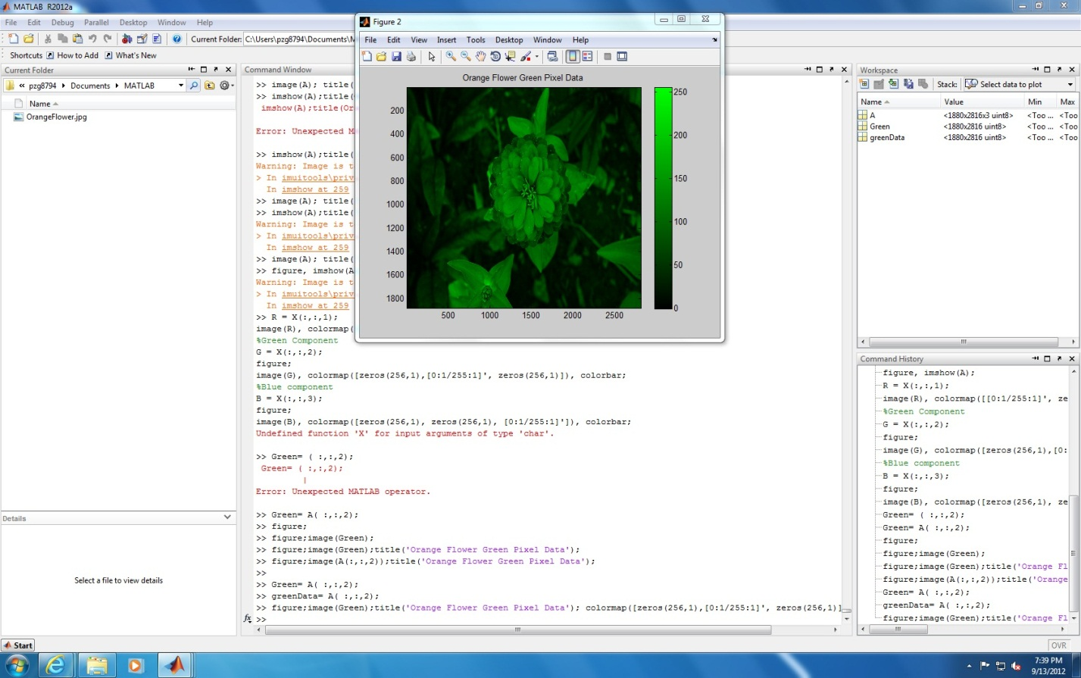
4. Assign the green pixel plane of data to variable greenData
>> greenData= A(:,:,2);

5. Using Matlab's colon operator ( no loops) extract rows 1675 to 1684 (inclusive) and columns 975 to 984 (inclusive) of the matrix greenData. Assign this region to variable im
>> A(1675:1684,:);
>> A(:,975: 984);

6. Display the values of the elements (NOT AN IMAGE) of the matrix im to the screen

7. Use Matlab's min and max functions to find the minimum and maximum values of im. Assign the values to minValue and maxValue. Display these values to the screen (these should each only be a single value. If you cannot get this to work properly, use the help function to obtain additional information on the min and max functions)
8. Multiply each value in im by 2(do not use loops to accomplish this). Assign the result to variable im2
9. Display the values of the elements in im2. Are the results what you expected? EXPLAIN YOUR RESULTS IN THE WRITE-UP PORTION OF THIS ASSIGNMENT.
10. Use Matlab's double function to convert im to double. Assign the results to variable imDouble1. Display the values of the elements in imDouble1
11. Multiply each value in imDouble1 by 2. Assign your results to imDouble12
12. Display the values of the elements in imDouble12. How do they differ from im2. EXPLAIN YOUR RESULTS IN THE WRITE-UP PORTION OF THIS ASSIGNMENT.
13. Use Matlab's im2double function to convert im to double. Assign the results to variable imDouble2.
14. Display the values in imDouble2. How do they differ from Double1. EXPLAIN YOUR RESULTS IN THE WRITE-UP PORTION OF THIS ASSIGNMENT
15 Use Matlab's mat2gray to convert im to type double. Assign the result to variable imDouble3. Display the elements in imDouble3. How do they differ from imDouble2? EXPLAIN YOUR RESULTS IN THE WRITE-UP PORTION OF THIS ASSIGNMENT
16. In the write up portion of this assignment in addition to describing the results from steps 1-13 above in a separate section summarize the differences between the following Matlab operations:
16a. double
16b im2double
16c. im2double(double(im))
16d. mat2gra

